Lab 5

ConfigUring file server resource manager

This lab contains the following exercises and activities:

|  |  |
| --- | --- |
| Exercise 5.1 | Installing File Server Resource Manager |
| Exercise 5.2 | Configuring Quotas |
| Exercise 5.3 | Managing Files with File Screening |
| Exercise 5.4 | Using Storage Reports |
| Lab Challenge | Enabling SMTP for FSRM |

BEFORE YOU BEGIN

The lab environment consists of student workstations connected to a local area network, along with a server that functions as the domain controller for a domain called *contoso.com*. The computers required for this lab are listed in Table 5-1.

Table 5-1

Computers Required for Lab 5

|  |  |  |
| --- | --- | --- |
| Computer | Operating System | Computer Name |
| Server (VM 1) | Windows Server 2012 | RWDC01 |
| Server (VM 2) | Windows Server 2012 | Server01 |

In addition to the computers, you also require the software listed in Table 5-2 to complete Lab 5.

Table 5-2

Software Required for Lab 5

|  |  |
| --- | --- |
| Software | Location |
| ADMXMigrator.msi, NMI32_x64.exe, System Center Monitoring Pack for File and Storage Management.msi, and Windows8=RT-KB2769034-x64.msu | C:\Software |
| Lab 5 student worksheet | Lab05_worksheet.rtf (provided by instructor) |

Working with Lab Worksheets

Each lab in this manual requires that you answer questions, take screen shots, and perform other activities that you will document in a worksheet named for the lab, such as Lab05_worksheet.rtf. You will find these worksheets on the book companion site. It is recommended that you use a USB flash drive to store your worksheets, so you can submit them to your instructor for review. As you perform the exercises in each lab, open the appropriate worksheet file using WordPad, fill in the required information, and save the file to your flash drive.

After completing this lab, you will be able to:

* Install and configure File Server Resource Manager
* Use Quotas to manage disk space
* Manage files with file screening
* Use Storage Reports

Estimated lab time: 60 minutes

|  |  |
| --- | --- |
| Exercise 5.1 | Installing File Server Resource Manager |
| Overview | During this exercise, you install File Server Resource Manager, which is used in the following exercises. |
| Completion time | 10 minutes |

**1.** Log in to Server01 using the **Administrator** account and the password **Password01.**

**2.** On Server01, at the top of Server Manager, select Manage and click Add Roles and Features to open the Add Roles and Feature Wizard.

**3.** On the Before you begin page, click Next.

**4.** Select *Role-based or feature-based installation* and then click Next.

**5.** When it asks for your destination server, click Next.

**6.** Scroll down, expand File and Storage Services, and expand File and iSCSI Services. Select File Server Resource Manager.

**7.** When you are asked to add additional features, click Add Features.

**8.** On the Select server roles page, click Next.

**9.** On the Select features page, click Next.

**10.** On the Confirm installation selections page, click Install.

**11.** When the installation is complete, click the Close button.

End of exercise. You can leave the windows open for the next exercise.

|  |  |
| --- | --- |
| Exercise 5.2 | Configuring Quotas |
| Overview | During this exercise, you use File Server Resource Manager quotas. |
| Completion time | 10 minutes |

**Mindset Question: You can configure quotas using NTFS or using FSRM. How do the quotas differ between NTFS and FSRM?**

**1.** On Server01, with Server Manager, click Tools > File Server Resource Manager. The File Server Resource Manager console opens.

**2.** Under Quota Management, click Quota Templates. Then right-click Quota Templates and select Create Quota Template. The Create Quota Template dialog box opens.

**3.** In the Template name text box, type **QuotaTemplate1**.

**4.** In the Space limit section, in the Limit text box, type **10** and specify the unit MB.

**5.** Select Soft quota, as shown in Figure 5-1.

|  |  |
| --- | --- |
| Question 1 | What is the difference between a hard and soft quota. |

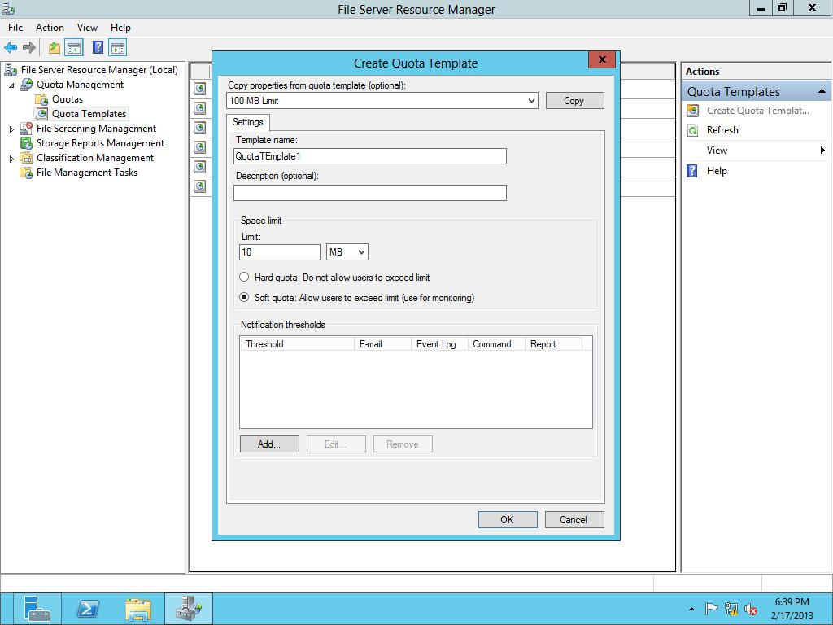

Figure 5-1

Creating a quota template

**6.** To add a notification, click the Add button. The Add Threshold dialog box opens.

**7.** Click the Event Log tab.

**8.** Click the Send warning to event log check box, as shown in Figure 5-2.

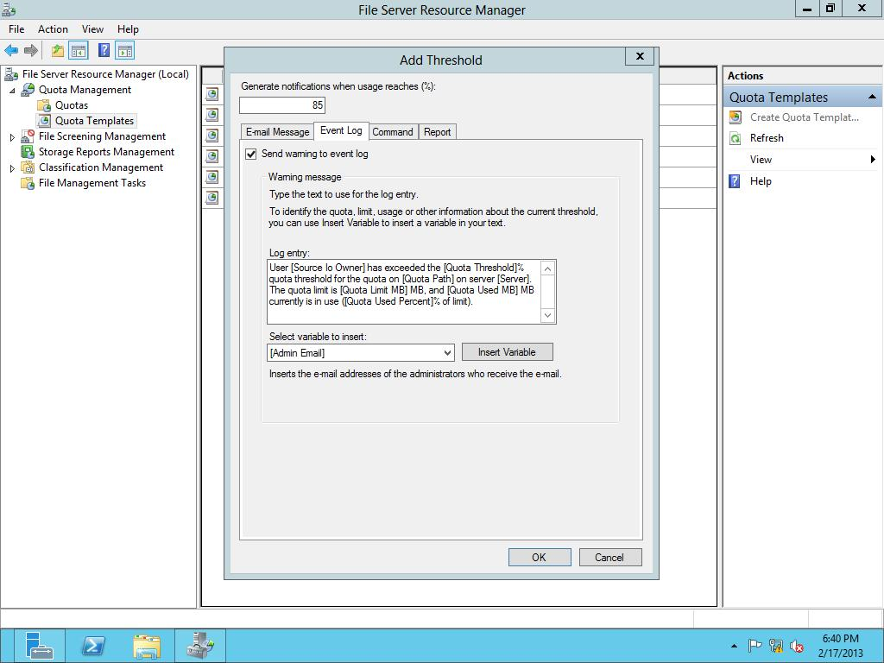

Figure 5-2

Adding an event log notification

**9.** Click OK to save your notification threshold and close the Add Threshold dialog box.

**10.** Click OK to close the Create Quota Template dialog box.

**11.** Click the Quota Templates node, and take a screen shot of the File Server Resource Manager window by pressing Alt+Prt Scr and then paste it into your Lab05_worksheet file in the page provided by pressing Ctrl+V.

**12.** Under the Quota Management node, click the Quota Templates node.

**13.** Right-click the QuotaTemplate1 and click Create Quota from Template. The Create Quota dialog box opens.

**14.** In the Quota path, type **c:\Share1** in the Quota path text box, as shown in Figure 5-3.

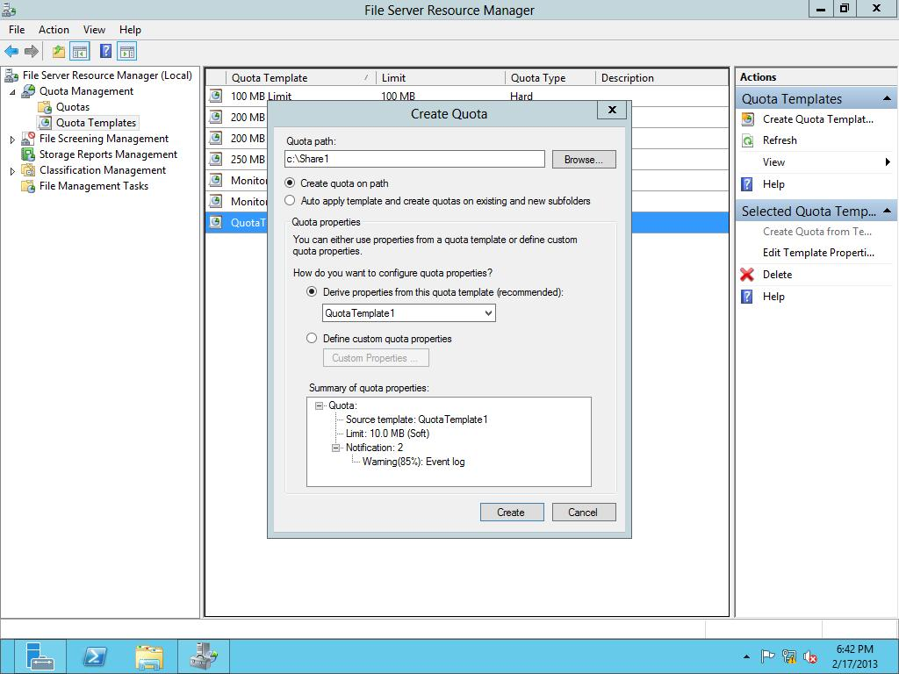

Figure 5-3

Creating a quota from a template

**15.** Click Create.

**16.** From the \\RWDC01\software folder, copy the following files to the C:\Share1 folder:

* ADMXMigrator.msi
* NM34_x64.exe
* System Center Monitoring Pack for File and Storage Management.msi
* Windows8-RT-KB2769034-x64.msu

**17.** On Server01, open the Event Viewer and look for an entry in the Applicationlogs showing that the quota has been exceeded.

|  |  |
| --- | --- |
| Question 2 | What event ID was used for the quota to be exceeded? |

**18.** Take a screen shot of the Event Viewer window by pressing Alt+Prt Scr and then paste it into your Lab5_worksheet file in the page provided by pressing Ctrl+V.

**19.** Close Event Viewer.

End of exercise. You can leave the windows open for the next exercise.

|  |  |
| --- | --- |
| Exercise 5.3 | Managing Files with File Screening |
| Overview | During this exercise, you continue to use File Server Resource Manager by using File Screening. |
| Completion time | 10 minutes |

**Mindset Question: You have a file server that ran out of disk space. Last week, there was plenty of space and this week, there is none. While looking at the files that are stored, you noticed that a couple of users have stored movie and music collections. How can you prevent this from happening in the future?**

**1.** On Server01, on File Server Resource Manager, click File Screening Management.

**2.** Click the File Groups node.

**3.** Right-click File Groups and select Create File Group. The Create File Group Properties dialog box opens.

**4.** In the File group name text box, type **FileGroup1**.

**5.** To include video files and add all files with the filename extension ram, type **\*.ram**, and then click Add.

**6.** Add the following filename extensions:

*.rm

*.avi

*.wmv

*.mpg

**7.** To add files to exclude, type **hello.avi** in the Files to exclude text box and click Add. The Create File Group Properties dialog box should look like Figure 5-4.

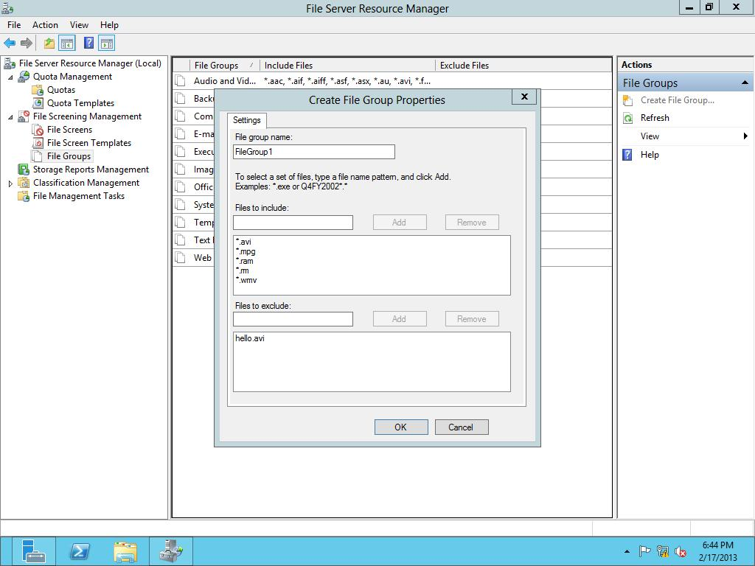

Figure 5-4

Creating file groups

**8.** Click OK to close the Create File Group Properties dialog box.

**9.** Under File Screening Management, click the File Screens node.

**10.** Right-click File Screens, and then click Create File Screen. The Create File Screen dialog box opens.

**11.** Type **C:\Share1** in the File screen path text box.

**12.** Click *Define custom file screen properties*, and then click Custom Properties. The File Screen Properties dialog box opens as shown in Figure 5-5.

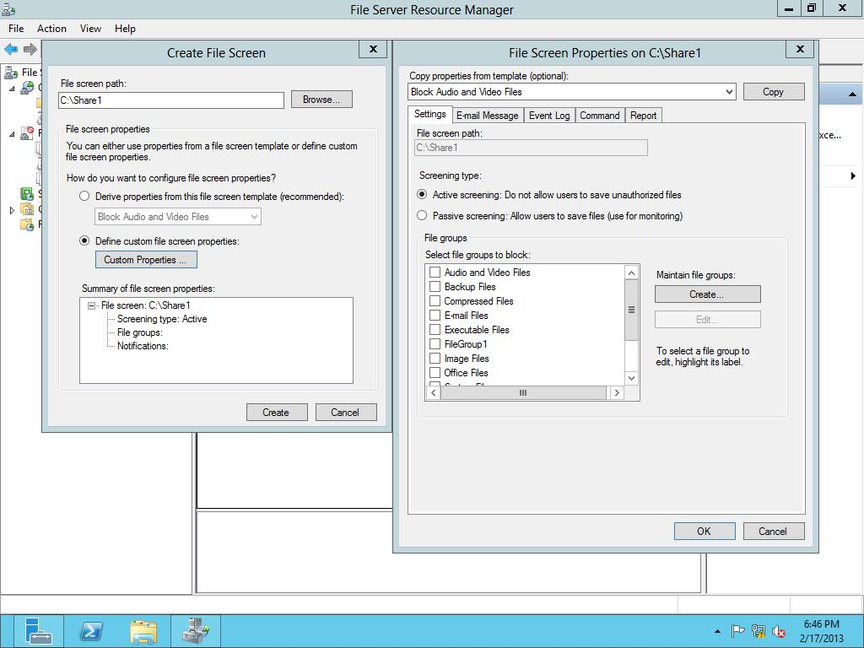

Figure 5-5

Creating a file screen

**13.** With Active screening already selected, click FileGroup1 in the File groups section.

**14.** To log an event, click the Event Log tab. Then click to select the Send warning to event log check box.

**15.** Click OK to close the File Screen Properties dialog box.

**16.** Click Create to create a new file screen

**17.** When it asks you to save the custom properties as a template, click *Save the custom file screen without creating a template*. Click OK.

**18.** With File Explorer, open the C:\Share1 folder.

**19.** In File Explorer, click the View tab.

**20.** Ensure that File name extensions is selected as shown in Figure 5-6.

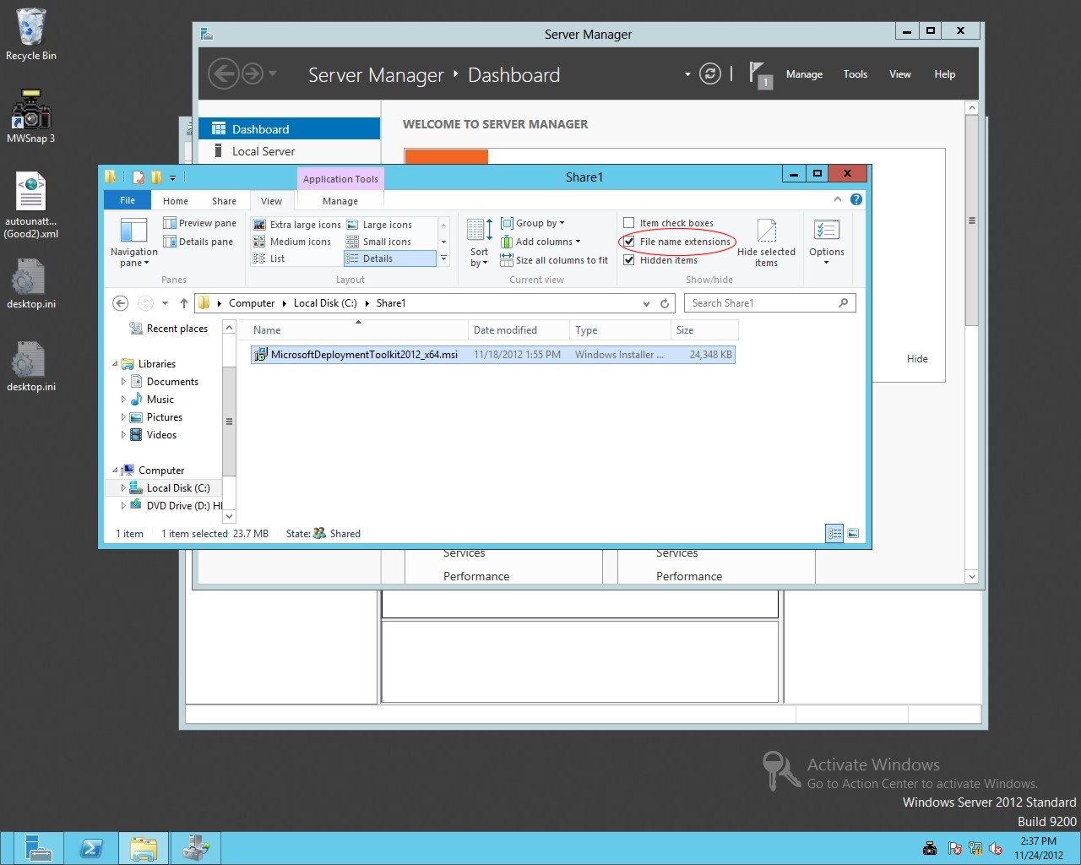

Figure 5-6

Showing File name extensions

**21.** On the Desktop, create a text file called **test1.avi**. Be sure that the file does not have the .txt filename extension. If it asks to change the filename extension, click OK.

|  |  |
| --- | --- |
| NOTE | Although the file has an .avi filename extension, it is really not a video file. It is just to demonstrate file screening. |

**22.** Copy thetest1.avi file to the C:\Share1 folder.

|  |  |
| --- | --- |
| Question 3 | What message did you get when you tried to copy the file? |

**23.** Click Cancel.

**24.** Rename the test1.avi file to **hello.avi**.

**25.** Copy the hello.avi file to the C:\Share1 folder.

**26.** Open the Event Viewer and access the Applicationlogs.

|  |  |
| --- | --- |
| Question 4 | What event ID was used for files that were not permitted for file screening? |

**27.** Close Event Viewer

**28.** Close the Share1 folder.

End of exercise. You can leave the windows open for the next exercise.

|  |  |
| --- | --- |
| Exercise 5.4 | Using Storage Reports |
| Overview | During this exercise, you execute File Server Resource Manager storage reports. |
| Completion time | 10 minutes |

**1.** On Server01, on File Server Resource Manager, click Storage Reports Management.

**2.** Right-click Storage Reports Management, and click Generate Reports Now.

**3.** When the Storage Reports Task Properties dialog box opens, click Quota Usage.

**4.** Click the Scope tab.

**5.** Click the Add button. Then browse to the C:\Share1 and click OK to close the Browse For Folder dialog box.

**6.** Click OK to close the Storage Reports Task Properties dialog box.

**7.** When the Generate Storage Reports dialog box opens, click OK.

**8.** When a folder opens, double-click the html file. Close message box, if needed, and view the Quota Usage Report.

**9.** Take a screen shot of the Performance Monitor window by pressing Alt+Prt Scr and then paste it into your Lab5_worksheet file in the page provided by pressing Ctrl+V.

**10.** Close Internet Explorer and File Server Resource Manager.

Lab REview Questions

|  |  |
| --- | --- |
| **Completion time** | **10 minutes** |

**1.** In Exercise 5.2, with File Server Resource Manager, what are quotas assigned to?

**2.** In Exercise 5.2, if you want to prevent a folder from getting too large, what type of quota should you use?

**3.** In Exercise 5.2, what methods can you use for notification when a quota is exceeded?

**4.** In Exercise 5.3, how do you prevent a user from saving unauthorized files?

**5.** In Exercise 5.5, what allows you to get a comprehensive report on how a disk is being used by the users?

|  |  |
| --- | --- |
| Lab Challenge | Enabling SMTP for FSRM |
| Overview | To complete this challenge, you must demonstrate how to enable SMTP for FSRM by writing the steps to complete the tasks described in the scenerio. |
| Completion time | 10 minutes |

You just got quotas and file screening configured properly. You now want to be e-mailed when quotas are exceeded and when users save unauthorized files. However, the messages are not being forwarded to the e-mail server. What should you do?

Write out the steps you performed to complete the challenge.

End of lab. You can log off or start a different lab. If you want to restart this lab, you’ll need to click the End Lab button in order for the lab to be reset.